Course Achievement Statistics System

General Idea:

The C program is a very useful toolkit in the academic setting which can take care of scores obtained by a maximum of 30 people. Such functions allow students to enter their examination results, calculate and show total marks obtained, perform statistical calculations and print out all records. The real power of the program lies in its capability to effectively manage and analyze educational performance hence it is an essential tool for all educators as well as learners that would wish to really track the progress of education.

Code:

#include <stdio.h>

#include <stdlib.h>

#define STU_NUM 30

typedef struct {

long student_number;

char name[100];

float score;

} Student;

Student students[STU_NUM];

int student_count = 0;

int Menu(void);

void ReadScore(void);

void AverSumofScore(void);

void StatisticAnalysis(void);

void PrintScore(void);

int main() {

int itemSelected;

printf("input student number (n<%d):\n", STU_NUM);

scanf("%d", &student_count);

while(1) {

itemSelected = Menu();

switch(itemSelected) {

case 1:

ReadScore();

break;

case 2:

AverSumofScore();

break;

case 3:

StatisticAnalysis();

break;

case 4:

PrintScore();

break;

case 0:

printf("End of program!\n");

exit(0);

default:

printf("Input error!\n");

}

}

return 0;

}

int Menu(void) {

int itemSelected;

printf("\nManagement for student's scores\n");

printf("1-input record\n");

printf("2-calculate total and average score of course\n");

printf("3-statistic analysis\n");

printf("4-list record\n");

printf("0-exit\n");

printf("please input your choice:");

scanf("%d", &itemSelected);

return itemSelected;

}

void ReadScore() {

int i;

for ( i = 0; i < student_count; i++) {

printf("\nEnter student number for student %d: ", i + 1);

scanf("%ld", &students[i].student_number);

printf("Enter name for student %d: ", i + 1);

scanf("%s", students[i].name);

printf("Enter score for student %d: ", i + 1);

scanf("%f", &students[i].score);

}

}

void AverSumofScore() {

int i;

int total = 0;

for (i = 0; i < student_count; i++) {

total += students[i].score;

}

float average = total / student_count;

printf("sum= %d, aver= %.2f\n", total,average);

}

void StatisticAnalysis() {

int i;

int categories[6] = {0};

for (i = 0; i < student_count; i++) {

if (students[i].score == 100) categories[0]++;

else if (students[i].score >= 90 && students[i].score < 100) categories[1]++;

else if (students[i].score >= 80 && students[i].score < 90) categories[2]++;

else if (students[i].score >= 70 && students[i].score < 80) categories[3]++;

else if (students[i].score >= 60 && students[i].score < 70) categories[4]++;

else categories[5]++;

}

printf("Fail <60 %d\t %.2f%%\n", categories[5], (float)categories[5] / student_count * 100);

printf("Pass 60-69 %d\t %.2f%%\n", categories[4], (float)categories[4] / student_count * 100);

printf("Medium 70-79 %d\t %.2f%%\n", categories[3], (float)categories[3] / student_count * 100);

printf("Good 80-89 %d\t %.2f%%\n", categories[2], (float)categories[2] / student_count * 100);

printf("Very Good 90-99 %d\t %.2f%%\n", categories[1], (float)categories[1] / student_count * 100); // Adjusted range from "90-100" to "90-99"

printf("Excellent 100 %d\t %.2f%%\n", categories[0], (float)categories[0] / student_count * 100);

}

void PrintScore() {

int i;

for (i = 0; i < student_count; i++) {

printf("Student Number: %ld, Name: %s, Score: %.0f\n", students[i].student_number, students[i].name, students[i].score);

}

}

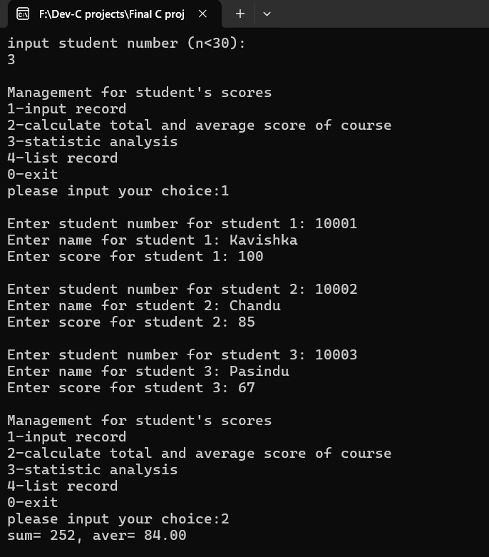Output (Screenshot):

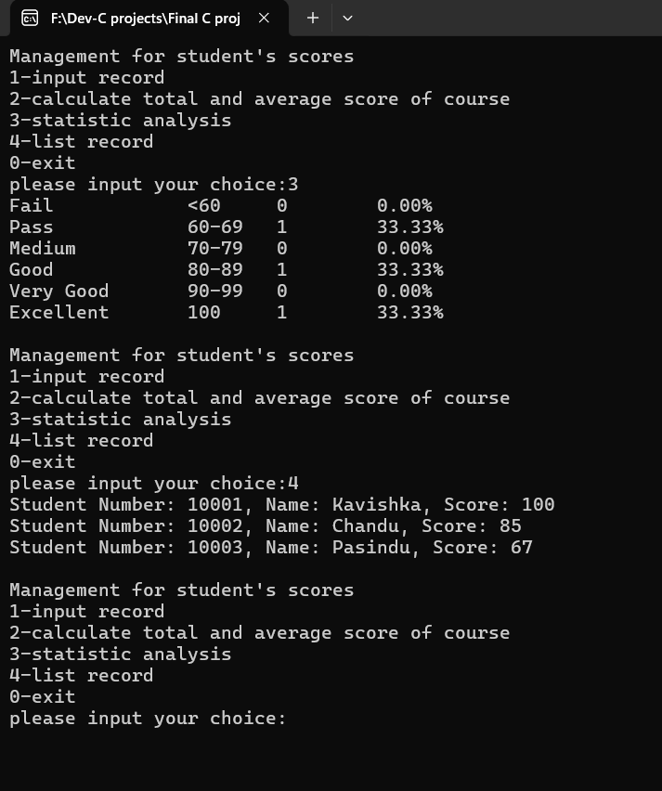

Tiangong University

International batch 2023

卡汀 -(Kartin)

Student No:(W2310805006)

Kavishka Dinuwan Suraweera

Passport No - N9632644